Project Overview:

Every Page Elements:

On each page, I have the same header, which includes my logo, which links to the index page, and my navigation bar, which I have achieved using a series of buttons which are styled in CSS. I have used bootstrap for a majority of my responsiveness, which will allow my website to be accessible for all different types of monitors and screen sizes.

Index:

On the index page, there is a banner photo which has a mini introduction to my website and the group. I have tried to keep the important information on the top and left the side of the screen, as this is where people tend to look, and where they absorb the most information. With this in mind I figured joining would be a priority. Therefore I placed button on the top left, which links to the contact page. Next to this, I have used JavaScript to get the day of the week, and it will update the page depending on what classes will be on that day. I also have added a Recipe Highlight, which has a link to each of my recipes, and when you hover over each one the picture will change, this has been done with JavaScript. Underneath I have social media icons, I used icons as they can be edited using CSS and are optimised for websites, the icons link to different social media websites. I also included a scroll bar which has news which would express updates to the website users.

About:

Here I have a simple description of what the group would do, which includes a link to the classes they provide. Below I used open source google API to place a google map image of where they are located.

Classes:

I have a table which I have styled using CSS which details the group's classes, I have also used CSS to make the table responsive, it will stack if the screen gets small enough. Below I have a button which will link to my class signup form. I have also included descriptions and pictures for all of my classes.

Class Sign Up Form:

I have used JavaScript to validate my form, which checks if the text boxes are empty, and if the email is in the correct format. I created my own database SQL server using XXAMPP to store the results of the form. I however, used my server as a local host, which mean this element of my code will not work outside of my computer. However below are pictures of the structure of my database, and what will happen when the form uploads to the server.

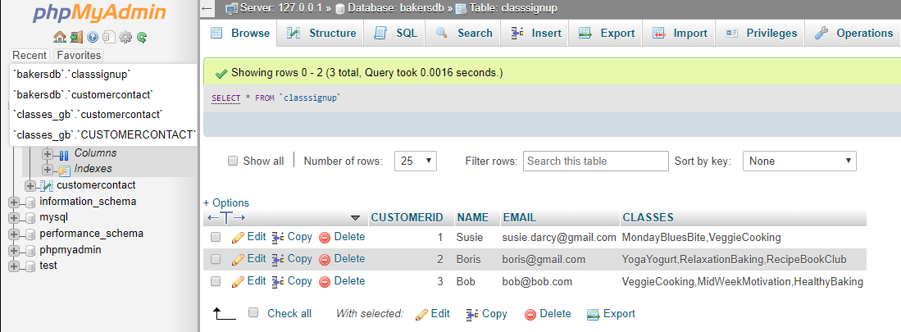

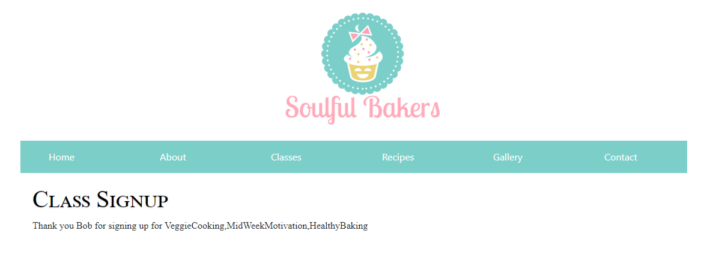

Recipes:

On this page I have links and pictures to other recipes, the website can easily be updated to add more recipes below if need. On the recipes themselves, I have used a mixture of linked and ordered lists to create a standard recipe page.

Gallery:

I have used JavaScript to create a slideshow gallery to display my images, the photos will change when you click either the side arrows or the circle below. I have styled the slideshow and buttons using CSS, but the functionality is done using JavaScript functions.

Contact:

On this page I have a form which is styled using CSS and the form is also validated using JavaScript to check to see if the text boxes are filled, and the email is under the right format. The form information is also uploaded into a different SQL database table, which will keep track of all the enquiries from users. Below is my database structure and the page if the site connects to the database.

